OUTPUT OF ASSIGNMENT 3

Starting server:

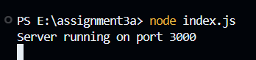

SERVED WEBSITE:

